An International Journal

# The Journal of American Science

**(*J Am Sci*)**

**ISSN 1545-1003 (print); ISSN 2375-7264 (online), Monthly**

**Volume 21 - Number 3 (Cumulated No. 205), March 25, 2025**

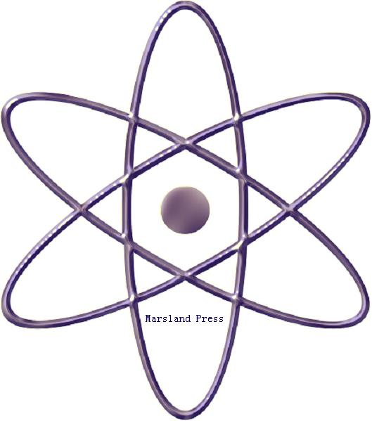

**Marsland Press**

**310 West 18th Street, New York, NY 10011, USA**

[**http://www.jofamericanscience.org**](http://www.jofamericanscience.org)**.**

[**http://www.sciencepub.net**](http://www.sciencepub.net)

[**editor@sciencepub.net**](mailto:editor@sciencepub.net)

[**editor@americanscience.org**](mailto:editor@americanscience.org)**;**

[**americansciencej@gmail.com**](mailto:americansciencej@gmail.com)

**718-404-5362**

# The Journal of American Science

(*J Am Sci*)

ISSN 1545-1003 (print); ISSN 2375-7264 (online); Monthly

The ***Journal of American Science*** is an international peer reviewed journal with a purpose to enhance our natural and scientific knowledge dissemination in the world. Any valuable paper that describes natural phenomena and existence or any reports that convey scientific research and pursuit is welcome. Papers submitted could be reviews, objective descriptions, research reports, opinions/debates, news, letters, and other types of writings that are nature and science related. All the manuscripts will be processed in a professional peer review. After the peer review, the journal will make the best efforts to publish the accepted valuable works as soon as possible.

**Marsland Press**

**310 West 18th Street, New York, NY 10011, USA**

[**http://www.jofamericanscience.org**](http://www.jofamericanscience.org)**.**

[**http://www.sciencepub.net**](http://www.sciencepub.net)

[**editor@sciencepub.net**](mailto:editor@sciencepub.net)

[**editor@americanscience.org**](mailto:editor@americanscience.org)**;**

[**americansciencej@gmail.com**](mailto:americansciencej@gmail.com)

**718-404-5362**

ISSN 1545-1003

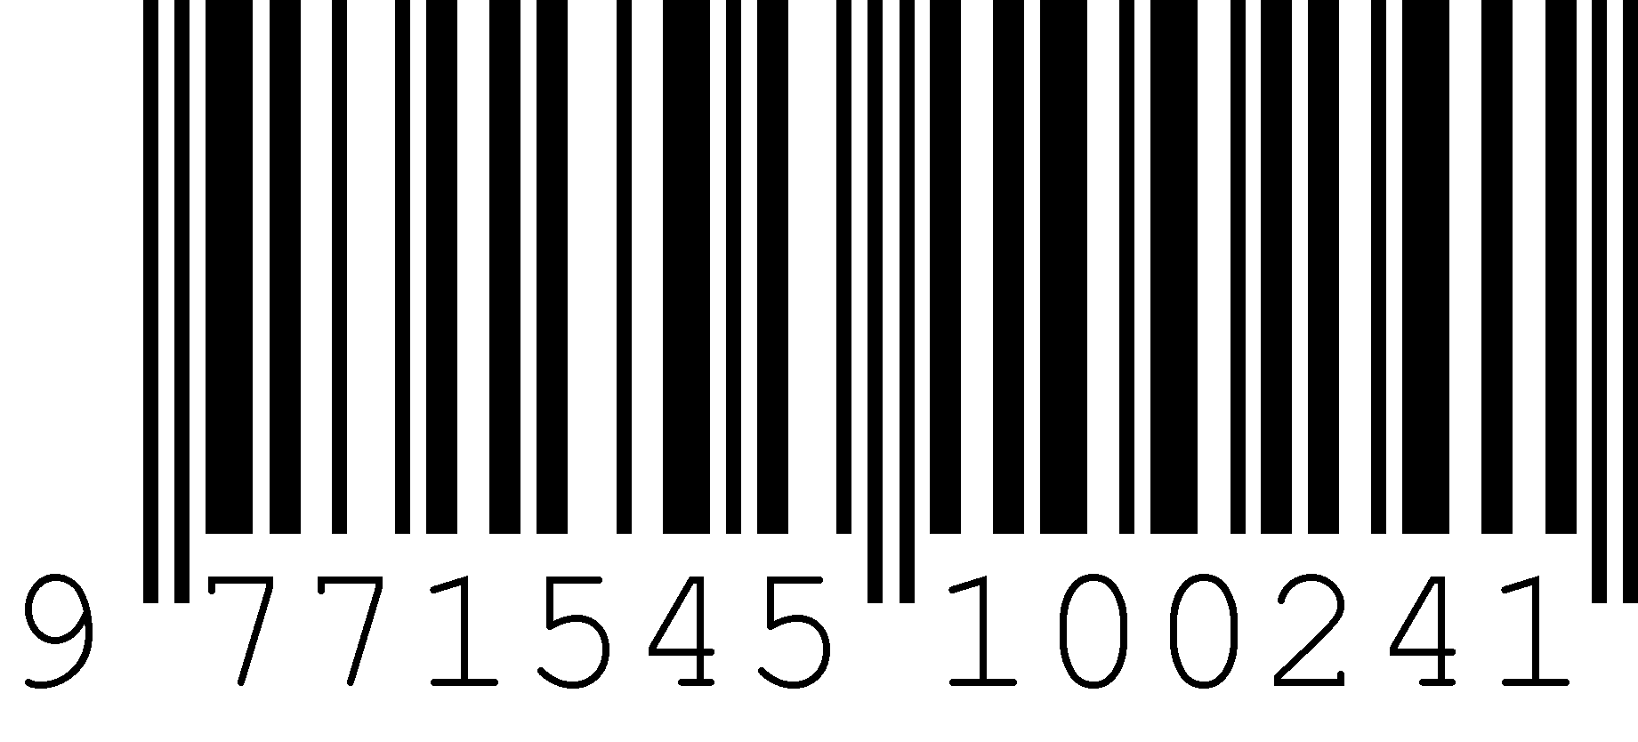

© 2025 Marsland Press